DATA FLOW DIAGRAM [DFD]

1. Context Level of Online Art Gallery

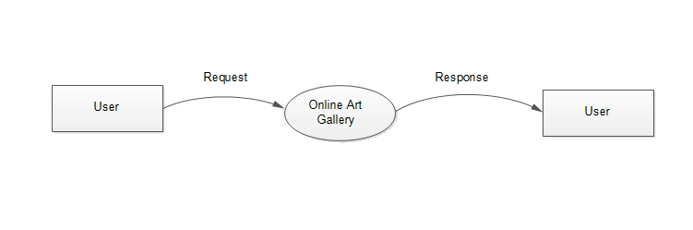

1. First Level DFD of Admin for Online Art Gallery

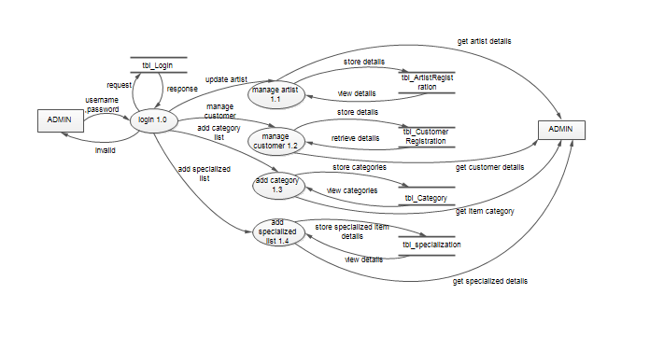

1. First Level DFD of Artist for Online Art Gallery

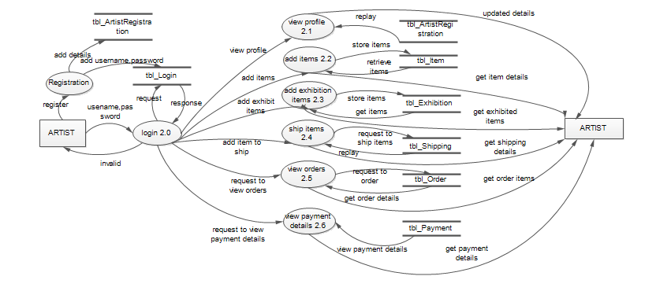

1. First Level DFD of Customer for Online Art Gallery

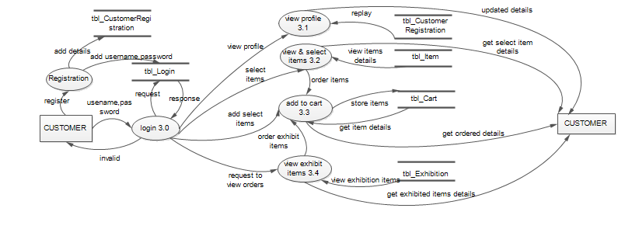

1. Second Level DFD of Customer For Add Cart

